
An Intelligent IoT and AI-Based Maternal Health Monitoring, Risk Prediction and Emergency Alert System

Submitted By
Name : Joya Rani Saha, Takia Yasmin
Department of IRE
Session : 2022-2023

Supervised By
Mostafiz Ahammed
Lecturer
Department of IRE

Farzana Akter
Assistant Professor,

Department of IRE

University of Frontier Technology, Bangladesh

Project Title: An Intelligent IoT and AI-Based Maternal Health Monitoring, Risk Prediction and Emergency Alert System

Project Overview:
Materna AI is an intelligent IoT- and AI-based system designed for real-time maternal health monitoring, risk prediction, fall detection, and emergency alerting, particularly for pregnant women in rural and low-resource areas. The system uses an ESP32 integrated with ECG, MAX30105, MPU6050, BMP280, and GPS modules to collect physiological, motion, environmental, and location data. The collected data are transmitted wirelessly to an AI backend for maternal health risk prediction. Six machine learning models, including Logistic Regression, Decision Tree, K-Nearest Neighbors, Gradient Boosting, XGBoost, and Random Forest, were evaluated. Random Forest achieved an accuracy of 93.08% and was selected to classify maternal health risk into Low, Mid, and High Risk categories.
For fall detection, a dataset of 6,446 images was used to evaluate YOLOv8n, YOLOv9t, YOLO11s, and YOLO26n. YOLOv8n achieved 99.7% validation recall, 99.4% mAP@50, and an inference time of 2.3 ms per image, supporting its use for real-time fall detection. The system also includes a 128$\times$64 SSD1306 OLED display, ECG-based buzzer alerts, GPS tracking, Bluetooth communication, and ThingSpeak cloud monitoring. A Flask-based web dashboard supports patient and doctor management, health risk assessment, appointments, consultations, and remote monitoring. The collected data are transmitted to the Flask backend and stored in a MongoDB database for monitoring and analysis. Overall, Materna AI integrates IoT sensing, machine learning, fall detection, and emergency support into a unified platform for continuous maternal health monitoring.

Comparison of Relevant Previous Studies and the Proposed Materna AI System:
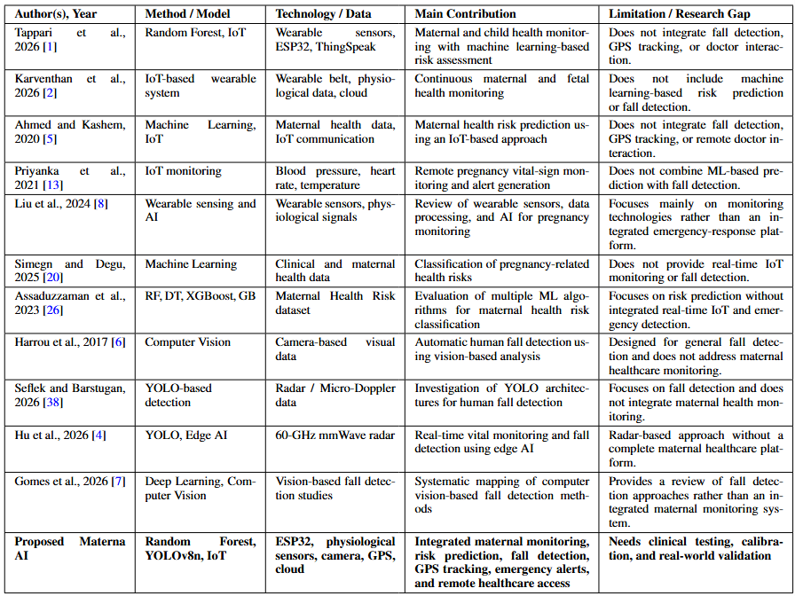

Objectives:
- To develop an IoT-based system for continuous real-time maternal health monitoring.
- To predict maternal health risk using machine learning.
- To detect fall events using YOLO-based computer vision.
- To provide GPS-based emergency location tracking and alerts.
- To enable remote monitoring through a cloud and web-based platform.

Circuit diagram of the proposed Materna AI hardware system:

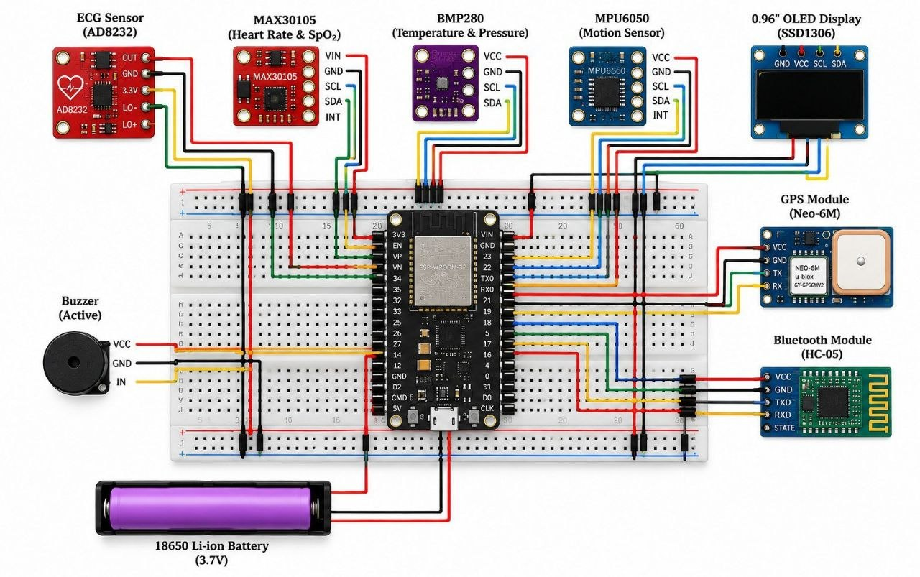
System architecture of the proposed Materna AI system:
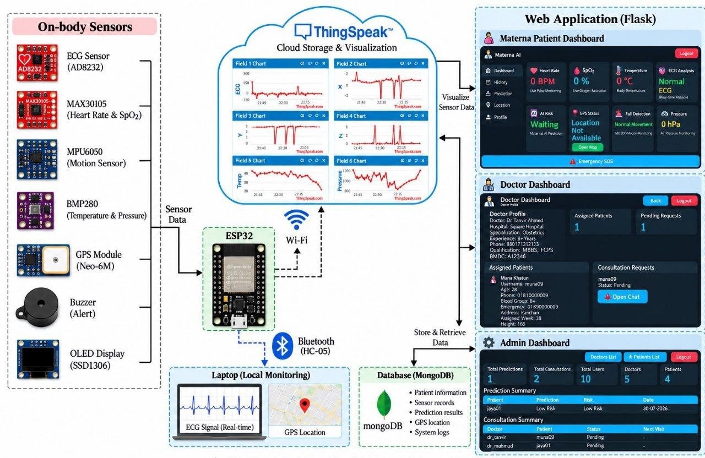
Estimated implementation cost of the proposed Materna AI system:

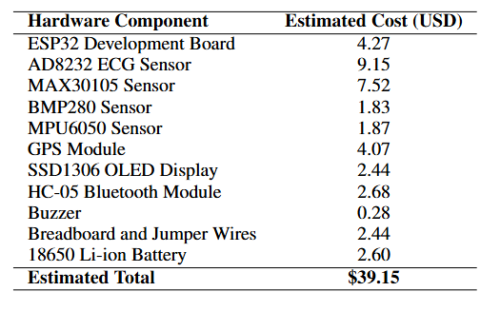
AI/ML Method:
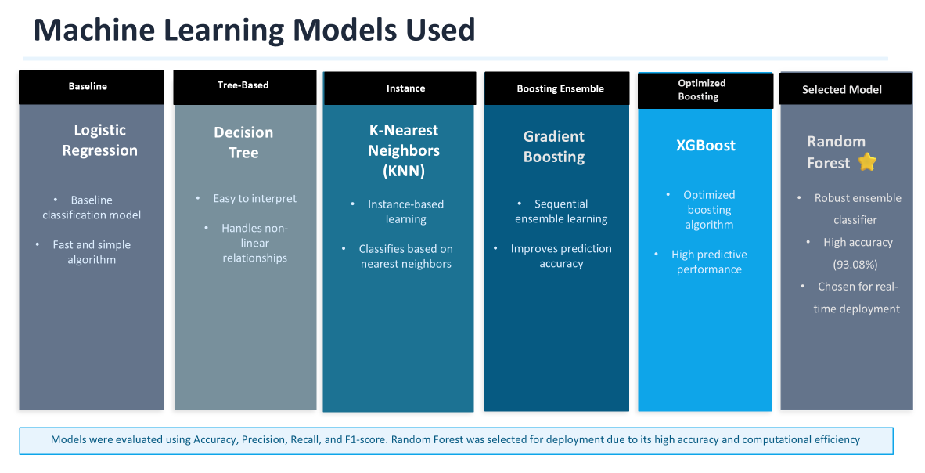

Random Forest achieved an accuracy of 93.08% and was chosen as the final model used for predicting maternal health risk.
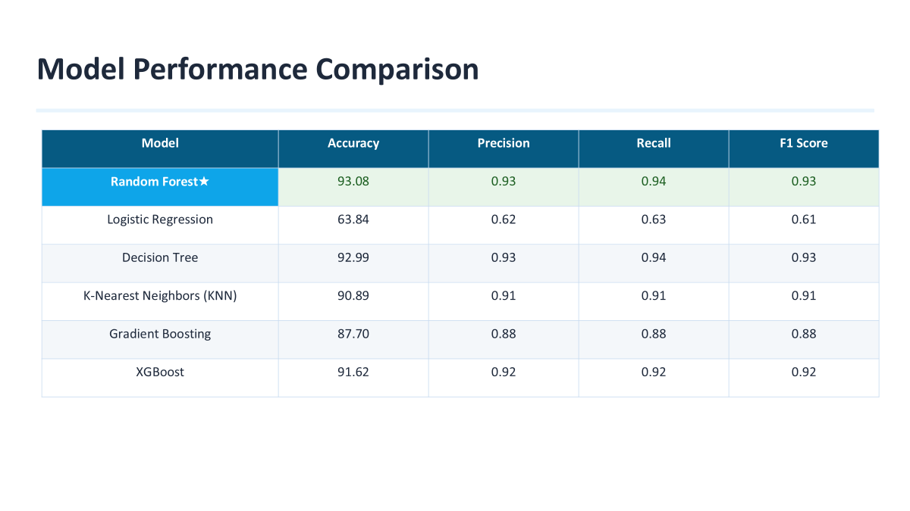
Confusion matrix of the Random Forest model for maternal health risk classification:
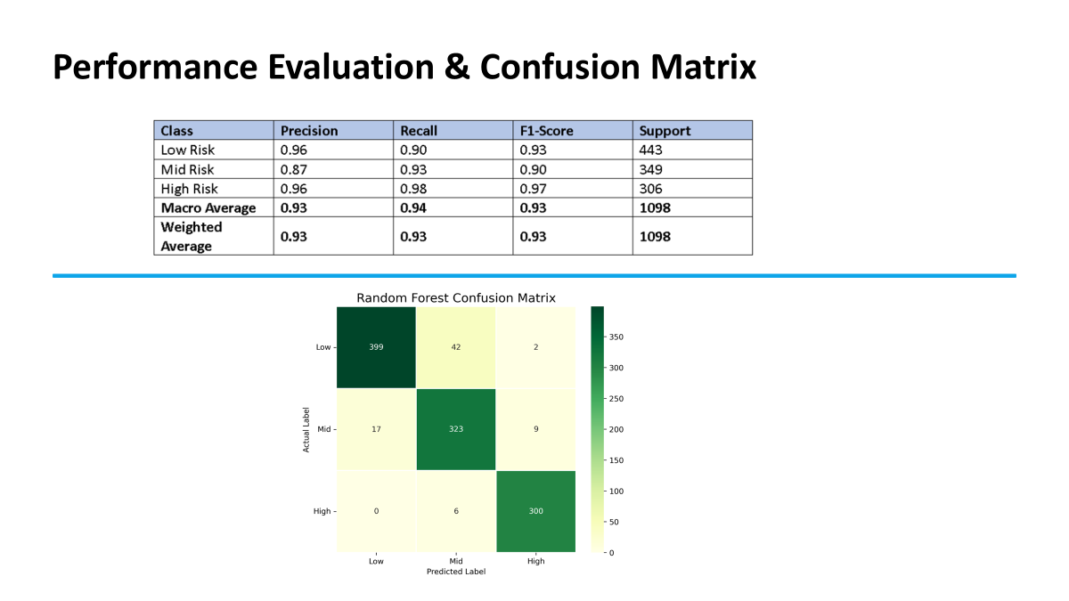
The confusion matrix was used to check how well the Random Forest model did when it came to classifying the three types of health risks. These types are called Low Risk, Mid Risk and High Risk. The confusion matrix shows how the models predictions compared to the results for each category. It also shows where the model made mistakes.

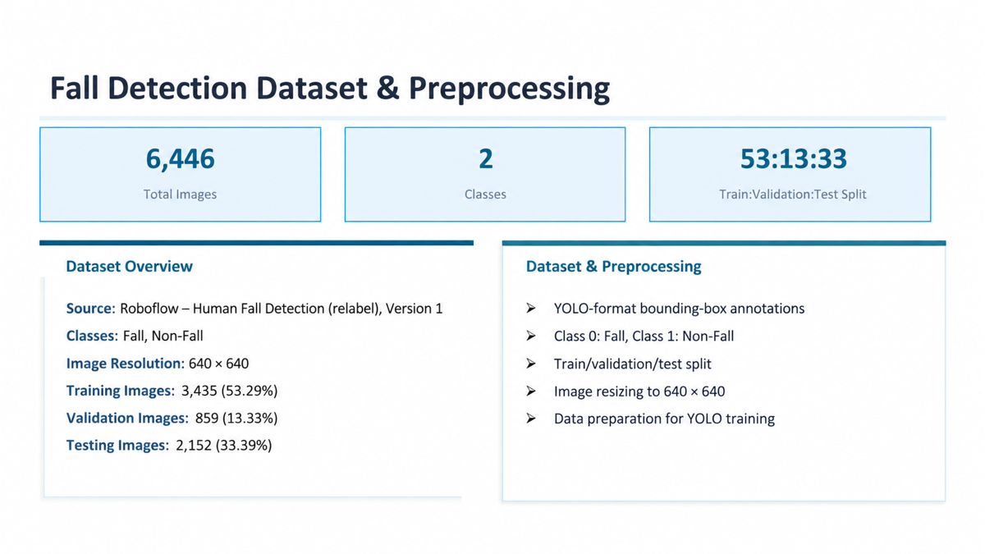
Four YOLO models, YOLOv8n, YOLOv9t, YOLO11s and YOLO26n were evaluated for fall detection using the dataset. Their precision, recall, mAP@50 and mAP@50-95 values were compared
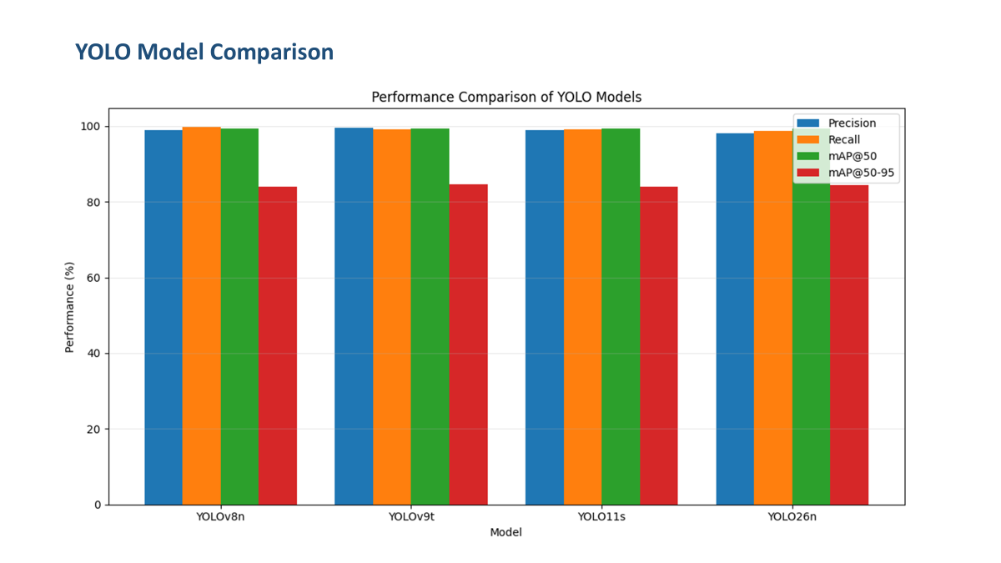
The training performance of the selected YOLOv8n model was checked over 30 epochs. The evaluation used precision, recall, mAP@50 and mAP@50-95.
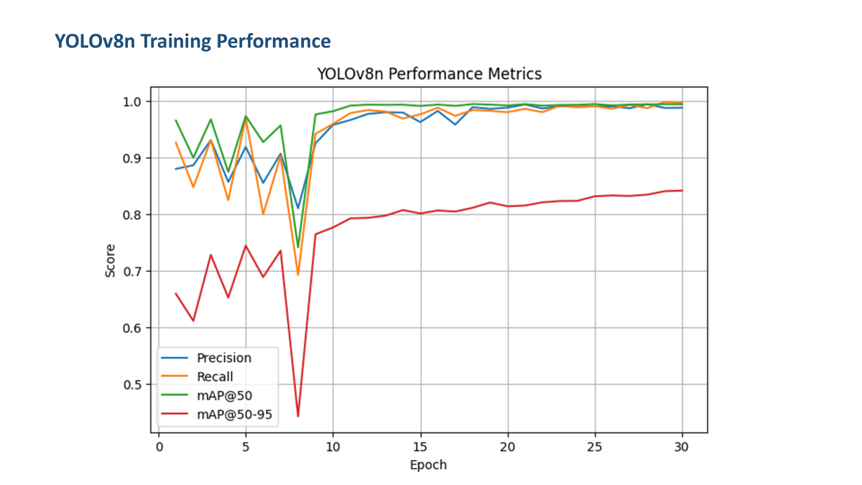

Results and Performance:
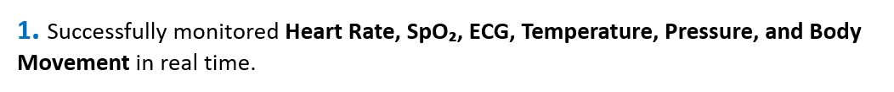
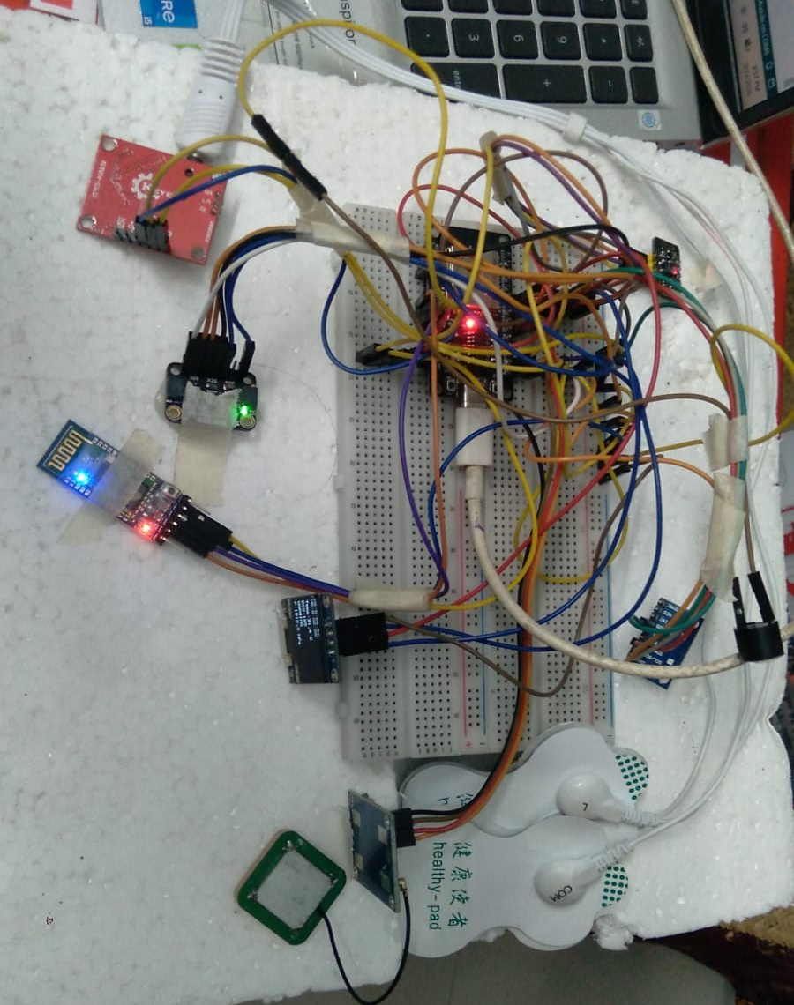
2. Sensor data were transmitted to the ThingSpeak cloud platform for continuous remote monitoring.
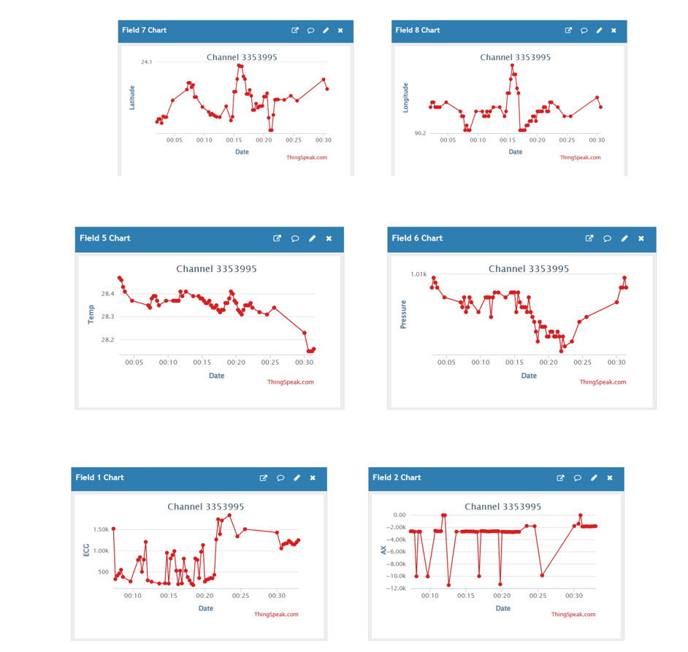
3. The GPS module accurately tracked the mother's live location and displayed it on Google Maps.

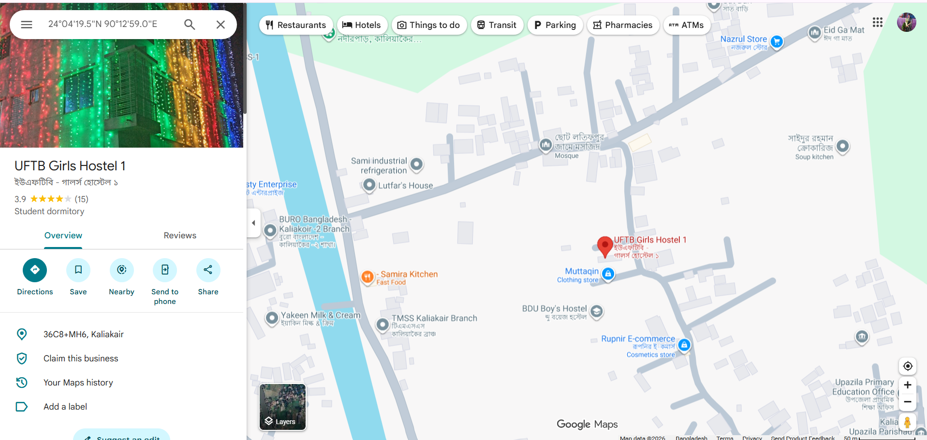
4. The bluetooth communication using an HC-05 Bluetooth module and a terminal application, on a smartphone. The ESP32 successfully connected to the HC-05 module. Transmitted ECG data wirelessly. I watched the ECG data stream come through the terminal without any delay. The received data included the ECG value and a Google Maps link generated from the GPS coordinates.
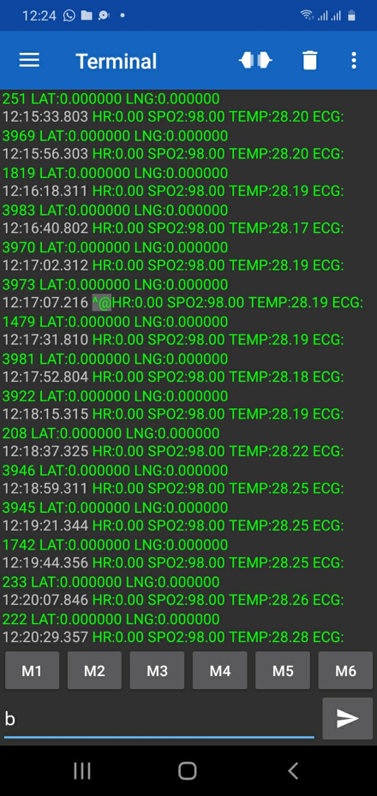
5. Achieved 93.08% prediction accuracy using the Random Forest model.
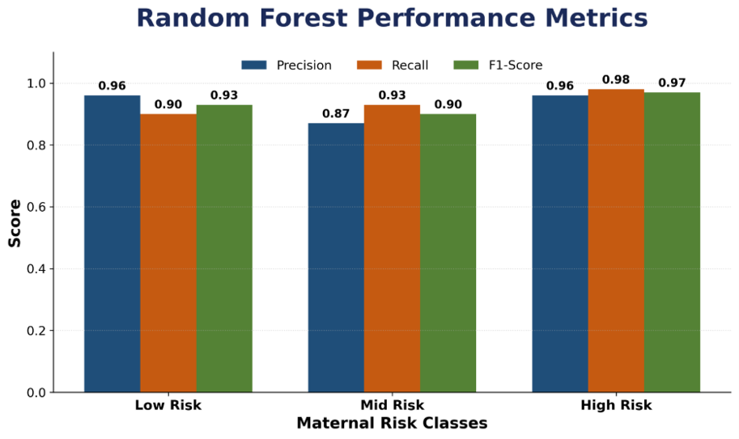

6. The fall detection system uses a webcam to watch the patient’s movements. The user can stop the fall detection system using the provided buttons. The fall detection system shows the current movement status, such, as normal movement. Helps identify possible fall incidents.

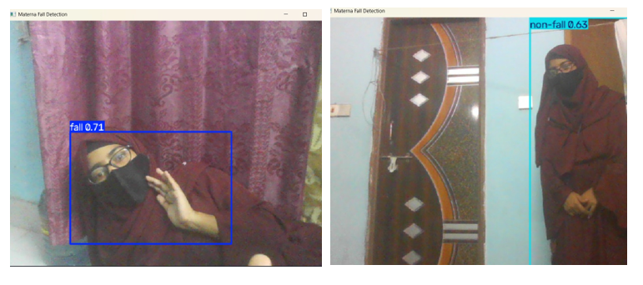

7. The Materna AI system offers a way to send alerts when there is a serious problem with a mothers health. If a dangerous situation or a fall happens the system creates a message with the patients details and information, about the pregnancy. This message is sent to the doctors phone number so the doctor can see it is an emergency and do what needs to be done.

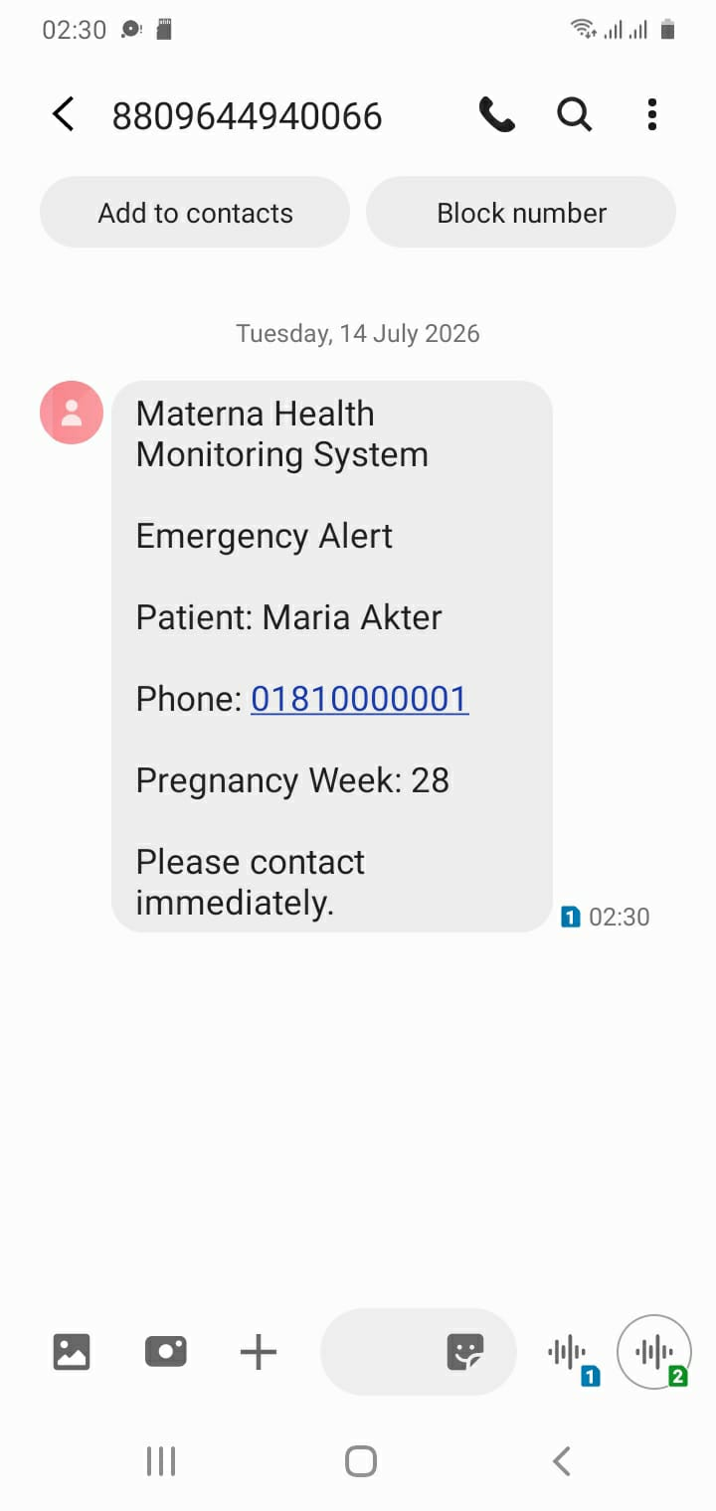
Conclusion:
The proposed Materna AI system offers a combined IoT and AI solution for keeping track of health predicting risks detecting falls and offering help in emergencies. The system uses ESP32 along with sensors to gather key data about the body, surroundings, movement and where someone is at any time for ongoing monitoring.The Random Forest model reached an accuracy of 93.08 percent when classifying health risks into Low, Medium and High levels. Also YOLOv8n worked well for detecting falls in time taking 2.3 milliseconds per image. The system also includes warnings based on ECG through a buzzer, tracking location using GPS, wireless communication and a web-based dashboard for watching over someone from a distance.In total bringing together sensors machine learning, fall detection and emergency alerts creates a single platform to help with continuous care, for mothers. The created prototype shows how these technologies can be used together to spot health issues quickly and offer support from away.

